AILT9019 · AI Literacy II
Project Proposal Template
Label Desk: cited, plain-language exhibition labels from one open-access collection
Due: Wednesday, 30 Sep (Week 4) · One submission per team, via the Moodle

1. Background
Who is this for, what is stuck, why it matters this semester, and who or what it is not for. Also state where the idea comes from: which topic-list idea(s) and how far they were adapted, an external idea, or an original idea. A figure is optional.
Who this is for: student and volunteer curators writing wall labels for a small campus or community exhibition.They are not subject specialists: no museum training, no register to ask, no catalogue they are licensed to quote. Their only source is the subject record the host institution can hand over - a spreadsheet row or a database entry written in curatorial shorthand.
What is stuck: The gap between the record and the label closes in two directions, and beginners fail in both. A record that reads “attributed to, 18th century, probably Mughal” gives no warning that the field cannot supplied. Writing one label by hand – record open, second source checked – takes 20-30minutes, so a thirty-object show is ten to fifteen hours of the semester’s spare time. Faced with that, beginners fill the gap from memory, and that is precisely where an invented fact enters a gallery text. The error is also the hardest kind to catch: an invented fact inside a fluent sentence reads exactly like a true one.
Why it matters this semester. It is a small text-in / text-out pipeline that can be built and tested well before Week 12, and it puts the course's own theme — citation, hallucination and refusal — at the centre of the artefact rather than in an ethics appendix. The users who most need the safeguard are the least equipped to notice its absence, which is what makes a machine-checked citation worth building.
Not for: museum registrars, art-market users, or anyone who needs authentication, appraisal, insurance valuation or rights clearance. Those requests are treated as out of scope and refused.
Where the idea comes from: an original idea, developed from the 'arts & culture' domain on the topic list and then narrowed to one user group, one task and one public dataset after the Week 4 scope test.

2. Project pipeline
End-to-end path: request → method → result, and what the team will actually build. A pipeline diagram is encouraged.
Input. One object record, identified by its catalogue number, taken from a fixed corpus — the open-access CC0 records of a single museum department (the team's first choice is The Metropolitan Museum of Art's Open Access dataset). The named fallback is the Art Institute of Chicago's CC0 Open Access dataset, which publishes the same five required fields under a comparable catalogue-number convention; the dataset decision is locked at the Week 5 checkpoint so that a stalled first choice cannot block the build. Whichever source is used, it is downloaded once and frozen locally as a JSON file so that a run needs no network at all, and the frozen copy is versioned with a checksum recorded in the README, so a reader can always tell which records a given output was drafted from.
Method, six steps. (1) load the record and validate it against a required-field list — title, object date, medium, place or culture, credit line; (2) if a required field is missing, stop and refuse, naming the missing field rather than filling the gap; (3) build a fact sheet in which every value keeps a pointer to the field it came from; (4) render an offline draft of 60–80 words from that fact sheet using fixed sentence templates, so the offline path is fully deterministic; (5) optionally pass the fact sheet and the draft to an LLM under a guardrail prompt that forbids new facts, and accept the rewrite only if it passes the automatic check specified below; (6) print the label with a citation list naming the fields used.
The automatic grounding check. Because the entire project rests on this one mechanism, it is specified here rather than assumed. The renderer never emits prose alone: it emits a list of claims, each a span of the label paired with the id of the fact-sheet field that produced it — for example {"text": "The vase was made in 18th-century Iran", "source_field": "object_date"}. The check then runs three tests on every claim. (a) Field existence: the named source field must be present and non-empty in the fact sheet, so a claim citing a field that was never supplied is rejected outright. (b) Value containment: every number, date and named entity in the claim text must occur in the cited field's value after normalisation — case-folded, punctuation-stripped and matched as whole tokens, so that "18th century" cannot be satisfied by "8th century". A claim introducing a value its cited field does not contain is rejected. (c) Citation resolution: every entry in the printed citation list must resolve to a field that genuinely exists in the record, so the list can never point at a field the record never had. In the model-on run the LLM is required to return the rewrite in the same claim-plus-field structure; a rewrite that loses the structure, cites a field it was not given, or fails (a)–(c) is discarded and the offline draft is printed in its place. Making the check exact and automatic is also what turns the 100% target in Section 3 into a measurable pass/fail requirement rather than an aspiration.
Result. The label, its citations, and a machine-readable status of either 'drafted' or 'refused' with a reason. What the team actually builds: one local command-line tool plus a minimal single-page browser view. It is a drafting aid for a curator, never an authoritative record.
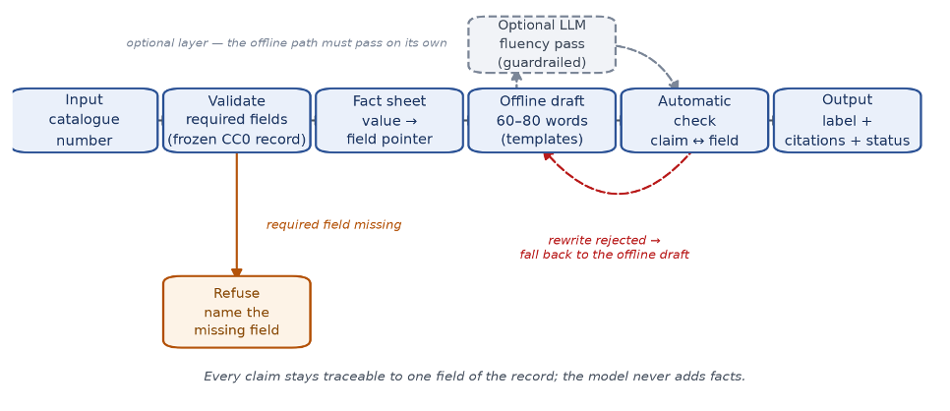
Figure 1. The must-have pipeline. Every claim stays traceable to one field of the record; a missing required field triggers refusal, and the model layer is optional.
- Language: Python 3.12+
- Core pipeline:​ standard library only — json for the frozen corpus, argparse for the CLI, plain string templates for the renderer. No framework, no database.
- LLM pass:​ official openai Python SDK behind the --llm flag (one call, temperature 0, prompt stored as a plain text file). Default run replays the frozen transcript, so no key needed.
- Tests/eval:​ pytest + our grounding-check script (also stdlib).
- Data:​ Met Open Access CSV → 20 records converted once into a local JSON file; versions pinned in requirements.txt.

3. Evaluation and test
How the team will tell the product works, including at least one case it should fail safely or refuse.
Golden set. 15 records drawn from the frozen corpus, chosen to a stated composition: ten well-formed records that should produce a label, and five that exercise a boundary or a refusal — for example a record with no object-date field and one whose culture field reads "probably Iran". For each record the team hand-writes the correct facts and the expected outcome. Each run is scored on three automatic checks, all computed by one evaluation script that ships with the repository, with its results table reported in the final submission.
What counts as a claim. The scorer does not read the label as prose; it reads the structured output of the renderer. The unit of scoring is therefore the claim object defined in Section 2 — a span of label text paired with exactly one source field — and that is what makes the three checks below exact rather than a matter of judgement.
- Factual grounding (must-have). Every claim's text must be contained in the value of the field it cites — test (b) in Section 2. Scored as claim-level precision: claims that pass divided by claims emitted. Required to be 100% on the golden set — a single invented fact fails the run.
- Citation coverage and resolution. Every claim must carry a non-empty source field that exists in the record (test (a)), and every entry in the printed citation list must resolve to a field and value that are really there (test (c)). Required to be 100%: a label with one uncited claim, or one citation that does not resolve, fails the run.
- Readability. 60–80 words and an average sentence length under 20 words, checked automatically against a fixed target band.
The boundary, worked through. Two decisions are easy to get wrong from a record alone, so the golden set fixes them in writing and the checker enforces them:

record field | A claim that passes | A claim that fails, and why
object date ca. 1750 | "made around 1750" | "made in the mid-18th century" — a period the record never states, so the derived phrase is not contained in the field value
object date 18th century | “made in the 18th century” | "made in 1750" — narrows a century to a year
culture probably Iran | "probably made in Iran" | "made in Iran" — drops the stated uncertainty; the name matches but the hedge is lost
culture Iran + place found in Egypt | "made in Iran" | "made in Egypt" — conflates two fields that are not interchangeable
In short: a claim may restate what its cited field says, including the hedges the record itself uses ("probably", "ca."), but may not sharpen, narrow, date or relocate it. Where a curator would accept the phrasing but the checker rejects it, the conservative direction wins and the rejection is logged; the report states that spurious-rejection count as a diagnostic rather than a pass condition, and the golden set records the expected outcome for each case so the log can be audited.
Safe-failure and refusal cases, which count as passes when the system refuses: (a) a record with no object-date field — the label must not state a period; (b) a record whose maker is recorded as unknown — the system must not name an artist; (c) a request about an object that is not in the frozen corpus — the system must refuse as out of corpus instead of describing something similar; (d) a request to state market value or authenticity — the system must decline as out of scope. In every case the refusal must name the specific reason — missing field, out of corpus, or out of scope — rather than a generic decline.
We run the whole set twice, once with the LLM layer enabled and once with it disabled; both runs must pass checks 1–3, which is how we show the result does not depend on the model. The model-on run is held to a no-regression rule: for every record the accepted rewrite must pass the same checks, and any rewrite that is rejected is replaced by the offline draft — so a model failure can cost prose quality but can never cause an invented fact or an unresolved citation. Failure is defined as any invented fact, any citation that does not resolve, or any case where the system answers instead of refusing.

4. Distribution and accessibility
How someone else can open the app: API setup, first use without a coding background, and (if in scope) other agent environments.
A classmate with no coding background should get from a fresh clone to one correct label in a single sitting, by following a six-step README. The README gives one command to paste — no arguments, no environment variables, no interpreter to choose — plus three sample catalogue numbers, the corpus checksum, and a screenshot of what a successful run prints. That walkthrough is the section's acceptance test: a classmate outside the team follows it once on their own machine before the mid-term check and reports where it broke.
The only optional setup is an API key for the LLM layer. Without a key — or without a network — the tool still runs and marks its output 'offline draft', so a missing key degrades the prose, not the pipeline. Readers who would rather not use a terminal get a single-page browser view of the same record: a should-have convenience, built after the must-have pipeline passes its checks, rendering the same label, citations and refusal reason, so nothing load-bearing rests on it. Both paths use semantic HTML, keyboard-only operation and WCAG AA contrast, and all output is plain text; refusals name the specific reason in plain language.
The offline fact-sheet-and-citation core is also packaged as one skill file so another agent environment can call it under the same guardrails, and because the corpus is frozen locally with cached demo outputs, the walkthrough survives an unavailable API or a dead network.

5. Ethics and risks
An explicit “does not”, plus main misuse or failure risks and how they are mitigated.
Does not: authenticate, appraise, price, insure or clear rights for any object; does not replace the curator's judgement or the museum's own record; and does not process personal data — the corpus contains none, and value and authenticity questions are refused outright. Refusal is a designed outcome here, not a failure state: the tool is built to say no when the record does not support an answer.
Risk 1 — a fluent label invents a plausible fact. Mitigation: facts may come only from the frozen record; every claim carries its source field; the grounding check in Section 2 runs on every claim and rejects any claim its cited field does not contain; and a missing required field triggers refusal by default. The check is deliberately conservative, and the rejections it makes of sentences a human would accept are logged and reported rather than quietly tuned away — the direction of error is chosen on purpose.
Risk 2 — the LLM rewrite drifts from the record even when the offline draft was correct. Mitigation: the rewrite is accepted only if it passes the same factual check and returns the same claim-by-field structure; the offline draft stays as the fallback; and the evaluation is repeated with the model switched off, so turning the model on cannot make a record worse.
Risk 3 — a label flattens or misstates cultural context, or states credit and rights incorrectly. Mitigation: the output always carries a fixed 'draft for curator review, not an official record' notice; the credit line and licence are reproduced from the record rather than paraphrased; hedges in the record — "probably", "attributed to", "ca." — are carried into the label rather than resolved, so the tool never states a firmer attribution than the museum does, and the vocabulary for culture and place is taken from the record's own fields rather than replaced with generic terms. A human review checklist ships with the README.
Limits of what this can claim. The evaluation measures whether a label is grounded, not whether it is good; taste, emphasis and audience stay with the curator. Overall stance: the system is deliberately informational and low-stakes. Its worst case is a wrong draft that a curator rejects, which is why the design targets drafts and refusals rather than decisions.

6. Checkpoints
Must-have and should-have acceptance items, plus a timeline to the Week 4 draft. A timeline figure is encouraged.
Must-have — all by Week 12:
l Frozen corpus (the primary source, or the named fallback if the first cannot be licensed or frozen in time), plus the required-field validator, with the corpus checksum recorded.
l Offline template renderer producing a 60–80-word label with a field citation on every claim.
l Refusal path for missing fields, out-of-corpus objects and out-of-scope requests.
l Golden set of 15 records with hand-written expected facts, and the evaluation script reporting claim precision, citation resolution and readability — passing in both the model-on and model-off runs. The script also reports the spurious-rejection count as a diagnostic.
Should-have — only once the must-have is finished:
l Optional LLM fluency layer behind the guardrail check.
l Single-page browser view.
l A second department's corpus, to show the pipeline is data-agnostic.
Does not: authentication, valuation, rights clearance, or any personal data.
Timeline: Week 4 — this proposal submitted and peer-reviewed. Week 5 — lock the corpus: confirm the primary source's licence and freeze it, or switch to the named fallback and freeze that, whichever is available first, and record the checksum. Weeks 6–7 — build the validator, the fact sheet and the offline renderer, and get one correct label end to end. Week 8 — add the refusal path and complete the golden set, including the boundary examples, with the team consultation before the revised proposal. Weeks 9–10 — add the optional model layer and the browser view, run the spurious-rejection log, and have a classmate walk the README with the accessibility checks on both paths. Week 11 — lock the evaluation, the recordings and the report. Week 12 — final deliverables and production pack.

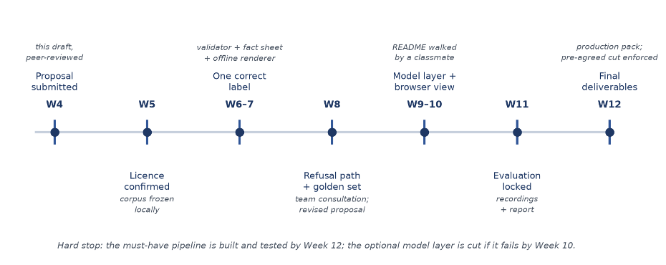
Figure 2. Timeline to the Week 12 milestone, with the pre-agreed cut at Week 10.
Pre-agreed cut: if the optional model layer is not passing the factual check by the end of Week 10, it is dropped, and the offline renderer is submitted as the whole system.

7. Response to reviewers
For every review your proposal received: cite the Reviewer ID, name the suggestion in a few words, state adopted / partially adopted / not adopted, and give one line why. No penalty for declining — but every review gets a visible response. Three rows are usually enough.
Reviewer ID | Suggestion (short) | Response | Why (one line)
R-8X68 | name a fallback dataset | Adopted | remove real schedule risk
R-DPHK | specify how the grounding check will actually detect unsupported claims and resolve citations | Adopted | Help avoid potential failure
R-A8J8 | add one worked example for a tricky boundary, such as object date vs. period, or culture vs. place | Adopted | the pipeline and evaluation cannot drift apart
R-8X68 | no special suggestion | \ | \
Add rows as needed — one row per review.

